**SPECCHIO VM Upgrade to Glassfish 4**

* Open SPECCHIO VM, login as root.
* Get Java 8:

http://www.oracle.com/technetwork/java/javase/downloads/jdk8…

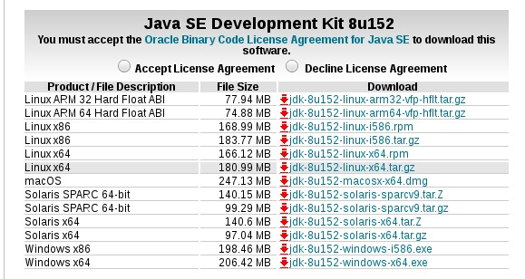

copy to: /user/lib/jvm/  
  
~~alternatives --install /usr/bin/java java /usr/lib/jvm/jdk1.8.0_152/jre/bin/java 2~~

~~alternatives --config java~~

~~There are 4 programs which provide 'java'.~~

~~Selection Command~~

~~-----------------------------------------------~~

~~* 1 java-1.8.0-openjdk.x86_64 (/usr/lib/jvm/java-1.8.0-openjdk-1.8.0.131-2.b11.el7_3.x86_64/jre/bin/java)~~

~~2 java-1.7.0-openjdk.x86_64 (/usr/lib/jvm/java-1.7.0-openjdk-1.7.0.131-2.6.9.0.el7_3.x86_64/jre/bin/java)~~

~~+ 3 /root/jdk1.8.0_152/bin/java~~

~~4 /usr/lib/jvm/jdk1.8.0_152/jre/bin/java~~

~~Enter to keep the current selection[+], or type selection number: 4~~

Setup **JAVA_HOME**, **JRE_HOME** and **PATH** environment variables

~~export JAVA_HOME=/usr/lib/jvm/jdk1.8.0_152~~

~~export JRE_HOME=/usr/lib/jvm/jdk1.8.0_152/jre~~

~~export PATH=$PATH:/usr/lib/jvm/jdk1.8.0_152/bin:/usr/lib/jvm/jdk1.8.0_152/jre/bin~~

~~Also put all above environment variables in~~**~~/etc/environment~~**~~file for auto loading on system boot.~~

- Change java path in /etc/.profile (gedit /etc/.profile) and .bashrc  
sudo gedit /etc/profile.d/.profile

sudo gedit /etc/bashrc

* Grep for all occurrences of jvm/jdk1.7 and change all of them!!!
* grep -R '1.7.0_80' ./
* grep -R '1.7.0_80' /etc

JAVA_HOME=/usr/lib/jvm/jdk1.8.0_152

Then restart the VM for all changes in path to take place. Check java version after reboot: java -version

* Get glassfish from <https://javaee.github.io/glassfish/download>, get Full Platform 4.1.2
* Unzip the glassfish archive, move glassfish4 directory to /opt
* Move old service start file: mv /etc/init.d/GlassFish_specchio ~
* Stop old glassfish: /opt/glassfish3/glassfish/bin/asadmin stop-domain
* Add java home to /opt/glassfish4/glassfish/config/asenv.conf[1]: AS_JAVA="/usr/lib/jvm/jdk1.8.0_152"
* copy the Gist contents to a new file: /usr/lib/systemd/system/glassfish.service
* run the commands:

systemctl daemon-reload

systemctl enable glassfish

systemctl start glassfish

* Check service: systemctl status glassfish
* Follow the install description of the original SPECCHIO server installation:

1. Copy the MySQL JDBC connector (mysql-connector-java-5.x.x-bin.jar) into $GLASSFISH_DOMAIN_HOME/lib/ext and re-start GlassFish (Note: restarting from the Glassfish administration interface appears to fail):

systemctl stop glassfish

systemctl start glassfish

1. Create a JDBC connection pool using the Glassfish administration interface:
   1. Visit Resources > JDBC > JDBC Connection Pools.
   2. Click “New”.
   3. Set “Pool Name” to specchio_web_pool.
   4. Set “Resource Type” to javax.sql.DataSource.
   5. Set “Database Driver Vendor” to “MySQL”.
2. Check database connection information for specchio_web_pool:
   1. Visit Resource > JDBC > JDBC Connection Pools > specchio_web_pool > Additional Properties.
   2. If using a URL to configure the database information, set BOTH Url and URL to jdbc:mysql://localhost:3306/specchio.
   3. Otherwise, set serverName, databaseName and port appropriately.
   4. Check that the settings for user and password match those used in the database configuration scripts used when initialising the SPECCHIO database (above).
   5. Test using the “Ping” button on the connection pool’s main page
3. Enable “Match Connections” for specchio_web_pool (Resource > JDBC > JDBC Connection Pools > specchio_web_pool > Advanced)
4. Create a JDBC Resource using the Glassfish administration interface:
   1. Visit Resources > JDBC > JDBC Resources.
   2. Click “New”
   3. Set “JNDI Name” to jdbc/specchio.
   4. Set “Pool Name” to specchio_web_pool.
   5. “Description” can be anything.

Realm Setup follows ….

/opt/glassfish4/glassfish/bin/asadmin deploy --force /opt/glassfish4/glassfish/domains/domain1/bin/specchio-webapp.war

Restart VM.

## Certificate

See Document ‘SPECCHIO VM Authentication Setup_V1.docx’ for details.

1. <https://gist.github.com/ricknoelle/39027844f4f7457d3e09>